|  |  |
| --- | --- |
| Course: | ENSF607 |
| Term: | Fall 2022 |
|  |  |
| Final Project – API Reference | |
| Version: | 1.0 |
| Date: | Nov 30 2022 |
|  |  |
|  |  |

## Registered User

To get All Users

http://localhost:8080/api/v1/user

## 

Get User by Email

[http://localhost:8080/api/v1/user/Email/{email}](http://localhost:8080/api/v1/user/Email/%7bemail%7d)

Post Mapping for Adding new User

http://localhost:8080/api/v1/user

Put Mapping for Updating a User

[http://localhost:8080/api/v1/user/{userId}](http://localhost:8080/api/v1/user/%7buserId%7d)

## Movie

To get all Movies

http://localhost:8080/api/v1/movie

Get Specific Movie

[http://localhost:8080/api/v1/movie/{movieTitle}](http://localhost:8080/api/v1/movie/%7bmovieTitle%7d)

*In progress does not work with multiple movies of the same title

## Ticket

Get all tickets

http://localhost:8080/api/v1/ticket

Get Specific Ticket

[http://localhost:8080/api/v1/ticket/{ticketId}](http://localhost:8080/api/v1/ticket/%7bticketId%7d)

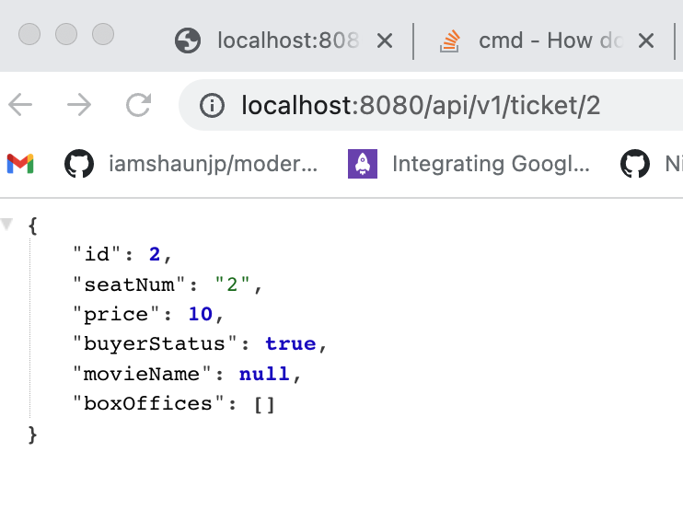

## Purchase Ticket

Put Request to

[http://localhost:8080/api/v1/boxOffice/purchase/{ticketId}/movie/{movieId}](http://localhost:8080/api/v1/boxOffice/purchase/%7bticketId%7d/movie/%7bmovieId%7d)

example.

Assigning Ticket 1 to Movie 1 (ticket 1 to BlackAdam)

## Cancel Ticket

Put Request to

[http://localhost:8080/api/v1/boxOffice/cancel/{ticketId}/movie/{movieId}](http://localhost:8080/api/v1/boxOffice/purchase/%7bticketId%7d/movie/%7bmovieId%7d)

## See all Movie ticket combos

http://localhost:8080/api/v1/boxOffice